Excluding ‘Resources’ from Team City Package Dependency Checks

By
Sarah Wade
BGL Junior Software Engineer Apprentice

Project Outline

My company uses ‘Team City’ as part of the main deployment process. Team city completes several actions on all code submitted to master branches in company git repositories, in order to get code ready for live deployment. Code cannot run in live if it does not pass these checks. One of these checks is to ensure that all packages dependencies are in date. If they are out of date by a specified margin, the build will fail and relevant people will be notified to complete an update on these packages. The issue involved with this is there are several packages created by Bgl, my company, which are frequently worked on. This causes frequent build failures, when many of the internal programs being slightly out of date, should not cause such high frequency build failures. The number of build failures based on out of date dependencies was becoming difficult to manage. My ticket was to exclude specific Bgl packages from triggering a build failure in order to reduce the build failure occurrences. The code I would be looking at would be inside a project called ‘dependency checker’. In dependency checker, the packages were currently being sorted and assigned an exit code. The code would be 0 if it passed, -1 for the process to exit. In addition, packages with a ‘-1’ exit code were highlighted in a package dependency report and colour coded. Red for failing, yellow for required update and green for passing. My task was to ensure that Test packages and packages ending including ‘Resources’ did not get assigned this -1 exit code when they were not at the latest version.

People Involved
Matt & Calum: Software Engineers, code reviewers
Phil: Technical Lead, acting product owner

Technologies Used:
Visual Studio Code IDE
Bitbucket, source control with git
Team City: Deployment Pipeline
Jira: Issue tracker

Project Setup

I began by speaking with the product owner, Phil, and asserting the requirements for the work and getting a project background from him. Phil highlighted the need for test packages to be excluded from being assigned the ‘-1’ exit code so that the team city build would not fail, he also asked for these specific builds to be included in the report but to be heighted as yellow instead of red. The packages outlined for filtering were packages ending with:
- “.Test”
- “.TestHarness”
- “.FunctionalTests”

Or if the package name is
- “.Resources”
So for example a package named “BGL.UI.Common.Resources” should not cause a build failure if it’s version is not the latest.
With this information, I added acceptance criteria to the jira ticket and filled in the details to ensure clarity for other team members. Once this was completed I marked the ticket ready for refinement and during a refinement session with my team assigned it points based on estimated complexity.
When my teams sprint began work on this ticket. In figure one you can see the completed jira ticket.
Fig 1: Completed Jira Ticket
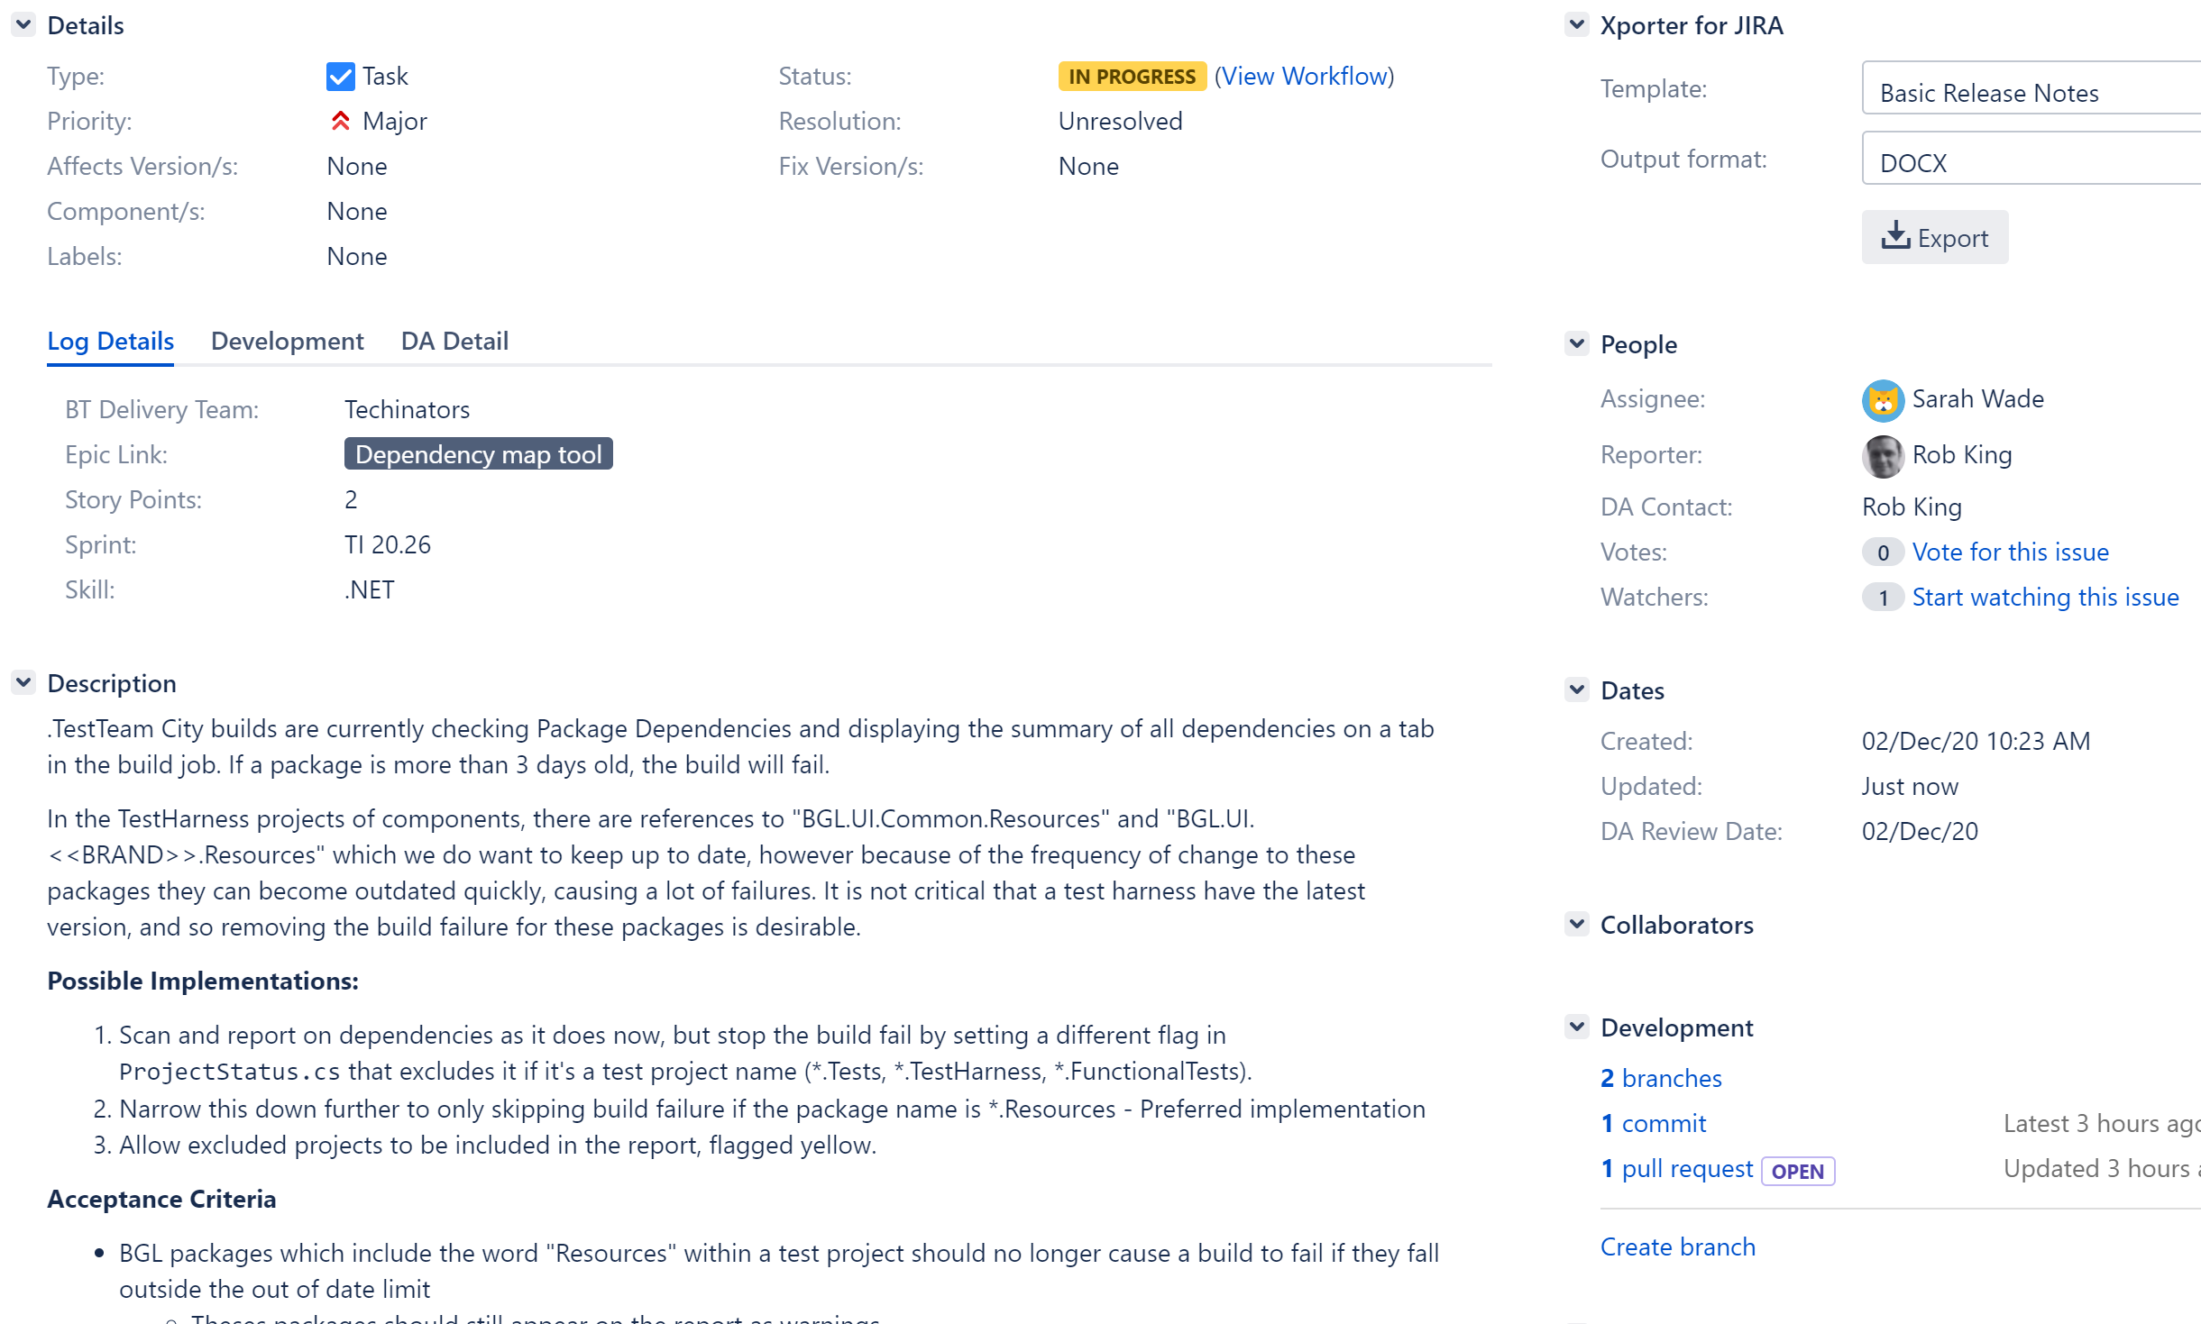

Code Implementation

I began by investigating how the current project worked and identifying where the changes would need to be made. I checked where the packages were being stored and what information was assigned to them. In the ‘PackageStatus.cs’ file the PackageStatus class was defined with the following attributes (fig 2).
Fig 2: PackageStatus Class

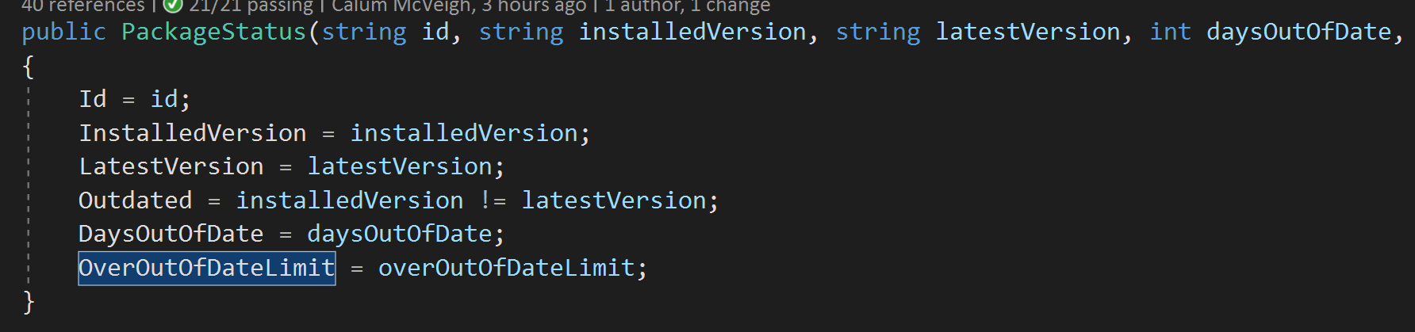

As you can see there were three parts of information that would contribute to the PackageStatus that might be relevant to the change I needed to make. The ‘OverOutOfDateLimit’ Boolean was the one I chose to work with, as this essentially would only be set to true if the package was firstly not the latest version, and was also past the predefined (15 days) ‘out of date limit’ decided by my company.
Within the ‘ProjectStatus.cs’ file inside another class called Project Status. This is where the main attributes were set and the packages were sorted into, below you can see the logic for this (fig 3).
Fig 3: Original Code for OverOutOfDateLimit
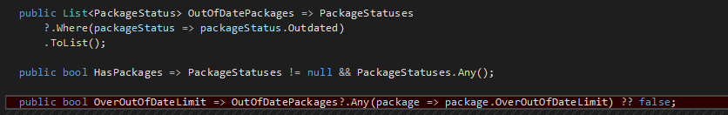
As you can see in Fig 3 the currently process was only filtering when the package had a ‘true’ OverOutOfDateLimit property, and was not particular about what type of package it was.
I began by firstly creating a test, in line with TDD principles. I created a test to assert that if a package contained ‘.Resources’ on the end, that the exit code would remain at its default, which should be 0.

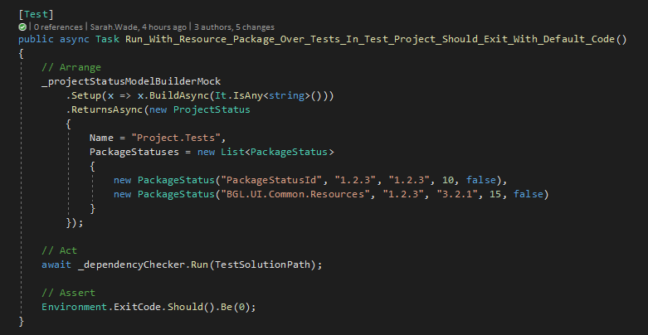
Fig 4: TDD Test for ‘.Resources’

With this test failing as expected, I decided to begin with altering the OutOfDateLimit Boolean. I added additional logic to filter for the “.Resources” packages, which would prevent the Boolean from becoming ‘true’ if the package contained “’.Resources”. I have split the below snippet (fig 51 / 5.2) into two halves to make it readable:
Fig 5.1: Beginning of new OverOutOfDateLimit logic

Fig 5.2: Second part of the logic

To explain what is occurring here the Get method for OverOutOfDateLimit used a lambda expression to see if there were any packages which are out of date. I added an Any method to evaluate a lambda expression (5.1). I added the logic seen in fig 5.2. Here if the package was not out of date and it did not contain “.Resources” it would return true, otherwise false.
I chose to use an ‘Any’ method above as it suited the needs of the required logic. The ‘Any’ methods checks whether any item in ‘OutOfDatePackages’ list satisfies the specific conditions outlined and returns true when satisfied. This was tidier than using a for loop, which would have been a bit larger and may have been required to be exported to a separate method; the Any method also served my purpose by ensuring each item was checked.
As you can see the second condition I added, using the && operator and the ‘!’ not operator together; I ensured that the packages containing “.Resources” would not return true, indicating further down the logic process that the exit code should be 0 for that package thus not causing a build failure. To ensure the logic was behaving as required I ran the unit tests, and confirmed all passed (fig 6).
Fig 6. All passing tests overview
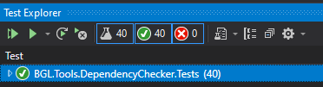

This implementation would satisfy the user story regarding filtering out “.Resources”.
Next, I began working on the other user story to filter out packages with:
- “.Test”
- “.TestHarness”
- “.FunctionalTests”
Again, I began by firstly creating a failing test. I passed the name parameter including an ending for each of the above cases, and asserted that the exit code for each of these would be 0. (fig 7).
Fig 7: Test for .FunctionalTest packages

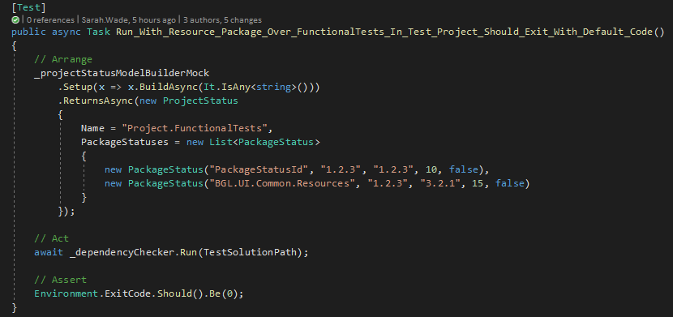
I included a new test case for each test to ensure that the packages created were not being affected by other running tests, thus ensuring that the test results remained valid.
I ran this test to ensure that I got the expected failure, which I did.
I began this section of work by creating a new Boolean called ‘IsTestProject” in the same scope as the Boolean OutOfDateLimit. I chose to use a lambda expression to return true or false depending on the outcome ( fig 8).
Fig 8 : IsTestProject Lambda Expression

I created the conditions seen in figure 8. I used the EndsWith method to evaluate whether the required strings were present. This would work as all Bgl package dependencies would only include a ‘test’ extension at the end of the string if it was present, not in the middle. I used an ‘or’ operator here as the conditions set out by the user story required a non-build failure if any, not all, of these test package dependencies were found. This Boolean therefore would return true if it found the name ends with TestHarness, Tests or FunctionalTests.
Next, I needed to use this Boolean to prevent the build failing if it returned true. For this I added an additional line of logic to the ‘OverOutOfDateLimit’ Boolean used previously. I wanted to add a check into this logic, as it was the key to deciding whether the exit code would be assigned a 0 or a -1 in the package status.
I implemented this by adding an extra condition after the lambda expression through use of a ‘&&’ operator. In figure 9 you can see that I included logic to include the ‘IsTestProject’ variable I created. To describe what is happening the logic now returned true if the package was over the out of date limit and not a test project or a test package ending with ‘Resources’. Otherwise it would return false, which would ensure that the exit code was set according to the requirements outlined by the product owner.
Figure 9: Logic added to OutOfDateLimit

I used the ‘or’ operator here (figure 10) as I wanted packages to pass through if either of the two conditions were true, as sometimes a Test package would not include ‘.Resource’ but the exit code should still remain 0 as the company does not want that case to cause a build failure.
Figure 10: Logical OR operator.

I used this alongside the ‘!’ not logical operator to create the behaviour that I outlined above and meet the requirements of this ticket.

With this completed I ran the created unit tests to ensure that they passed, which they did. This indicated that the work completed fulfilled the requirements of the ticket as the correct exit code was assigned to the packages dependent on what type they were. I created additional unit tests to cover each of the test cases, such as for “FunctionalTests” and ran them again to ensure the correct behaviour.
Next, I began to look at refactoring my code and decided that one small change to the large ‘OR’ statement I used in figure 8 could be reduced. I removed the ‘FunctionalTests’ expression and the ‘.’ From the ‘Tests’ one so that ‘Tests’ would not cover both conditions without breaking my other logic (fig 11).
Fig 11: Refactored Bool ‘IsTestProject’

I re ran the unit tests to ensure they passed and then pushed my code in git with a commit message (fig 12).
Figure 12: Code pushed to Bitbucket repository

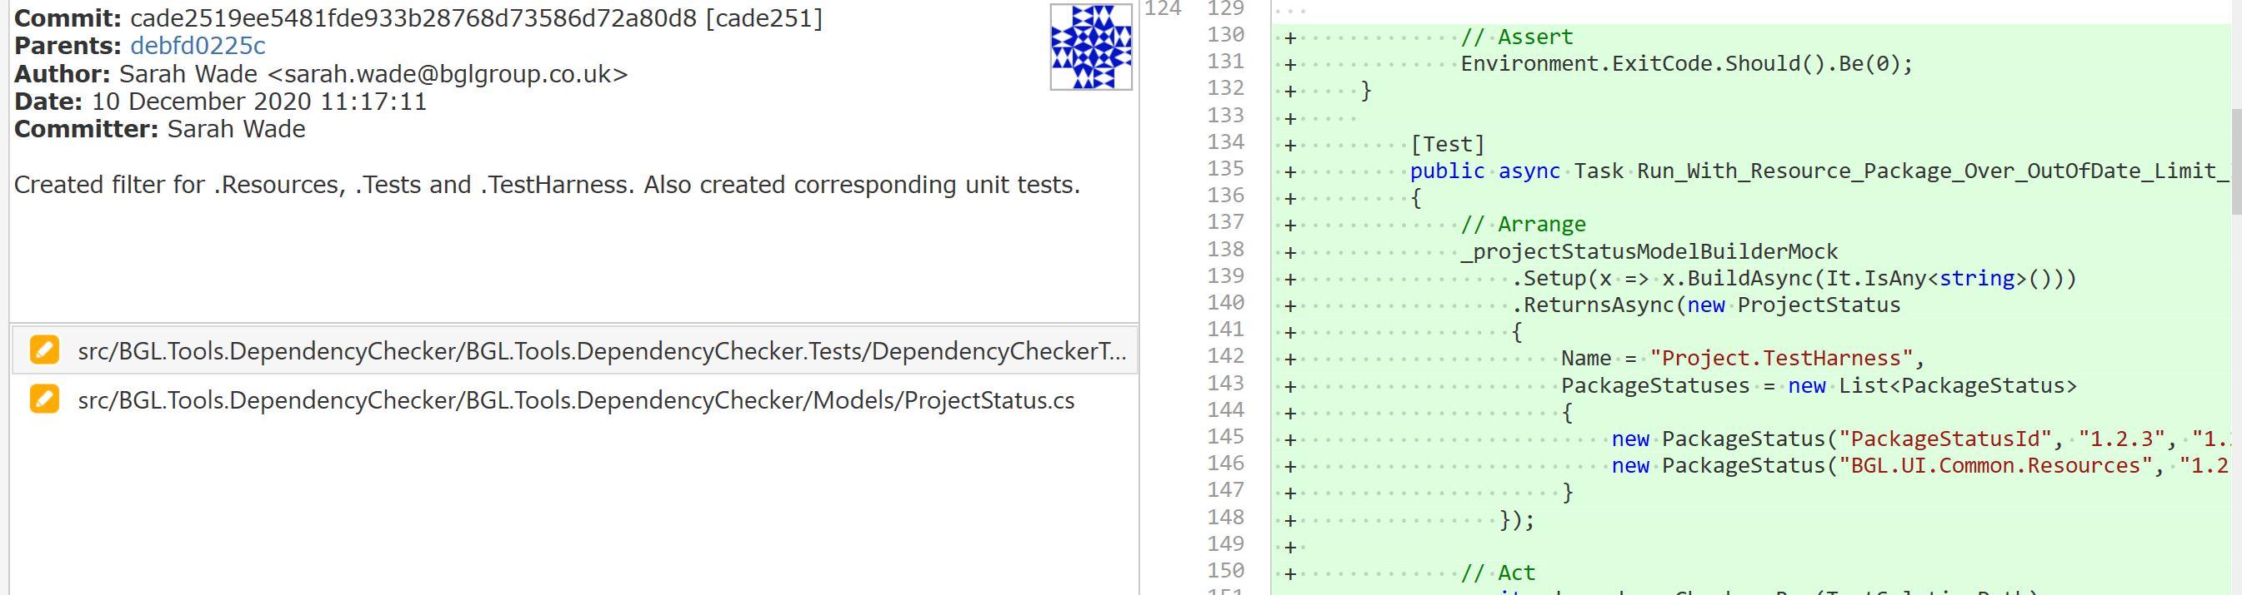
I also submitted a pull request (fig 13) for a technical lead to review before the code is merged into the live version.
Fig 13: Open Pull Request
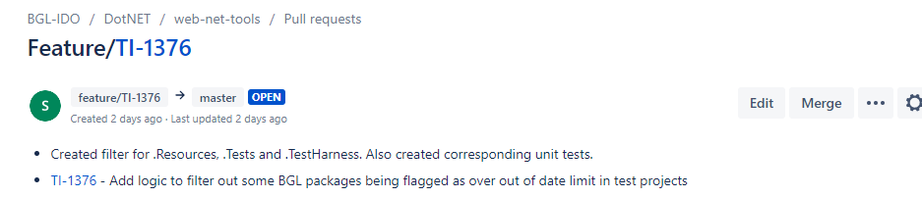

Conclusion
The outcomes of this ticket helped prevent an unnecessary high frequency of build failures in Team City, which in the future will save my company resources for higher priority changes. The out of date packages would still be picked up as ‘out of date’ in the end report as I did not alter the ‘Outdated’ variable that the report used, thus enabling them to still be flagged for updates as required. However now if they are out of date they would not cause a build failure, which was the purpose of this work.
I am pleased with the implementation I created. In reflection, I would have liked to have exported the logic I created on the ‘OverOutOfDateLimit’ variable into its own separate function, which would be more in line with SOLID principles. Additionally, if I had created this separate function, a more logical place to store it would have been in the projects model.

